Mark your calendars and begin preparing for the Village's annual recycling event. Huntley residents can take advantage of the following Green & Clean programs on April 26, 2025.
Entrance to the Municipal Complex events will be at Haligus and Main Street. Except for event traffic, Main Street will be closed from Haligus to Ruth Road. For safety and efficiency, everyone is to remain in their vehicles. Volunteers will remove items from your car. Residents are encouraged to come later in the day as there is typically no line.
HUNTLEY RESIDENTS ONLY (ID'S WILL BE CHECKED)
Electronics Recycling - 9am to Noon (or until dumpsters are full) | Municipal Complex (10987 Main Street)
The Village will be accepting your unwanted residential-only electronics at the Municipal Complex parking lot. Volunteers will be on hand to unload your vehicle - please stay in your vehicle. Due to the popularity of this free event - expect long lines. Due to Space Limitations, only 1 TV OR 1 Computer Monitor will be accepted per vehicle.
Acceptable items include:
- Cell Phones
- Tablets
- Cable Receivers
- Computers
- Digital Converter Boxes
- Digital Video Disc Players
- Digital Video Disc Recorders
- Electronic Keyboards
- Electronic Mice
- Fax Machines
- Microwaves
- Printers
- Portable Digital Music Players
- Power Tools
- Satellite Receivers
- Scanners
- Small Scale Servers
- Toaster Ovens
- Vacuum Cleaners
- Video Cassette Recorders
- Video Game Consoles
Printer Cartridge Recycling - 9am to Noon | Municipal Complex (10987 Main Street)
We are collecting all empty printer ink cartridges. In partnership with Fox River Valley Chapter DAR, the cartridges will be sent to a recycling center in exchange for a donation. The donation will be put towards local charity events.
Paper/Document Destruction - 9am to Noon | Municipal Complex (10987 Main Street)
No more than 2 banker boxes per household of residential documents for destruction (or until the truck is full) will be accepted at the Municipal Complex parking lot.
Spring Cleaning Drop Off - 9am to Noon | 11415 East Main Street at Donald Drive
Volunteers will unload your vehicle.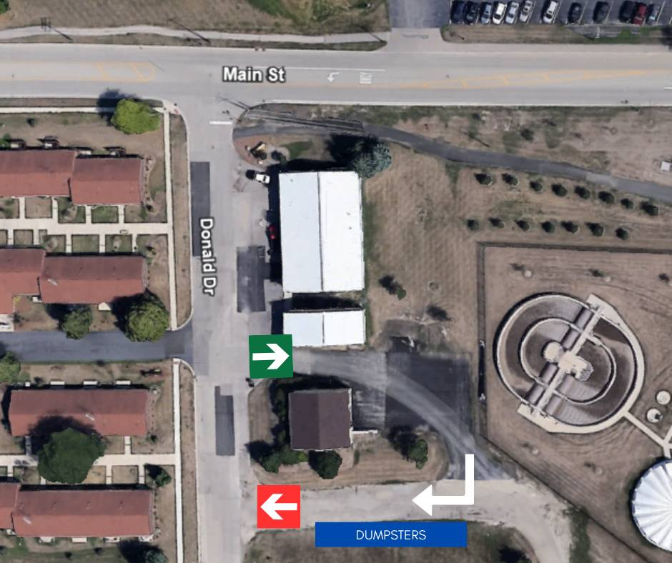
The following items will NOT be accepted at this site:
- Yard waste/grass clippings/branches, etc.
- Hazardous Waste
- Liquid waste (basically any liquids)
- Batteries (all kinds)
- Motor Oil
- Tires
- Electronics
- White Goods (refrigerators, freezers, dehumidifiers, stoves, ovens, etc.) - to discard White Goods, contact your wastehauler and set up a special pick-up
- Medical Waste
Lions Club Eyeglass Collection & Recycling - 9am to Noon | Municipal Complex (10987 Main Street)
The Lion’s Club will donate them to help improve the quality of life for children and adults living in low and middle income communities around the world.
Gently Used Book Drive - 9am to Noon | Municipal Complex (10987 Main Street)
Bring your gently used books to the Municipal Complex to be donated to non-profit organizations. Encyclopedias will not be accepted.
FOR EVERYONE
Wastewater Treatment Plant Tours - 9am to 1pm (last tour begins at Noon) | 12601 W. Main Street
Tours take approximately 1 hour.
Culver’s Kids Coloring Contest - April 21-April 30 | Culver's of Huntley (12950 IL-47)
Pick up a coloring sheet at Culvers of Huntley, Huntley Area Library, or Huntley Village Hall (10987 Main Street) from April 21 — April 30, and bring your best coloring work back to Culvers of Huntley by April 30 to get a free scoop! No purchase is necessary.

